ITI ZIMBABWE STUDY CLUB · UPDATE 2026
ITI Zimbabwe’s Inaugural International Conference
A Letter of Thanks and Progress Update
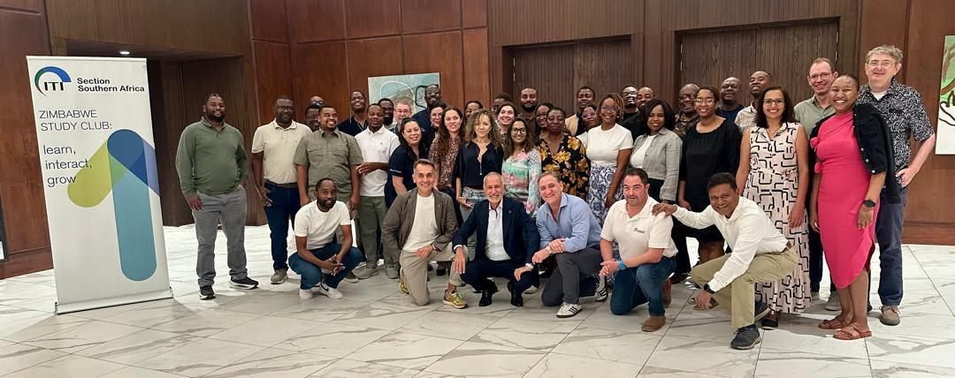
Delegates, speakers and organisers with the ITI Zimbabwe Study Club banner.
Dear ITI Southern Africa Leadership Team, Sponsors and Partners,
On behalf of the ITI Zimbabwe Study Club, we are delighted to report the successful completion of our inaugural international conference and to express our sincere gratitude to everyone who helped make it possible.
5  Zambian members in the club | 11  members at the Cape Town ITI Congress, April 2025 | 6  Foundation course students in 2026 | 2  full days of conference programme

WHERE THE IDEA BEGAN
The concept was inspired by the leadership of the ITI Southern Africa Committee and the successful ITI Education Days and International Scientific conferences hosted in South Africa in recent years. These experiences encouraged us to bring a similarly meaningful educational opportunity to Zimbabwe, supporting the growth of Implantology and giving our members access to exceptional international expertise closer to home.
A CLUB THAT KEEPS GROWING
Over the past three years, The Zimbabwe Study Club has grown steadily. By the end of 2025, we recruited three new members in Zambia, bringing our Zambian membership to five. We now make a note to acknowledge our Zambian colleagues and call ourselves the Zim-Zam Study Club.
The ITI Foundation-level course has also provided an important pathway for attracting and developing new members. Our student participation was steady with two Zimbabwean students joining in 2023, 2024 and 2025. However in 2026 our attendance jumped to five Zimbabwean students and one Zambian student. A visit by Dr Ridhwaan Hafferjee and a promotional Study Club meeting in Bulawayo in August 2025 helped inspire three new enrolments in the 2026 Foundation course from Bulawayo alone. This is testament to the value of extending our outreach beyond our location and creating opportunities for colleagues to engage with ITI education.
RECOGNITION FOR OUR MEMBERS
We are equally proud of our members’ commitment to the wider ITI community. Our club won the prize for being the first club to have all members’ subscriptions paid for the following year on two consecutive occasions, for 2025 and 2026. We also received the prize for the highest club attendance at the ITI Education Congress in April 2025, with 11 members travelling from Zimbabwe and Zambia to attend the ITI Congress in Cape Town in April 2025.
FROM AMBITION TO CONFERENCE
Building on this momentum, and with additional club funds available, Study Club Directors Dr Milan Djorjevic and Dr Sheetal Bhaskar embarked to undertake something significant for implant education in Zimbabwe. The aim was to give back to our members through a personal, engaging and meaningful educational experience. From this ambition, our inaugural international conference took shape.
In April this year we hosted Dr Sphe Mpungose and ran a full day event on fundamentals and basics of implant surgery including a hands-on experience sponsored by Straumann. This event also helped us to raise funds from non member attendance.
In September, we hosted “Restorative Excellence Implantology - from fundamentals to advanced concepts”. We were privileged to welcome Dr Sergio Piano and Dr Gianluca Podda, renowned speakers from Italy, who generously agreed to travel to Zimbabwe for the two-day programme. Having Dr Piano share insights from material he is preparing for his forthcoming ITI World Symposium presentation was a particular privilege, giving our delegates an early glimpse of content being developed for an international audience. Both speakers brought expertise, generosity and a willingness to engage closely with our delegates.
Our heartfelt thanks go to ITI Southern Africa, Straumann and Ivodent for supporting this event. We are especially grateful to Gary Hockly of Ivodent for sponsoring Dr Jean van Lierop as our keynote regional speaker and hands-on trainer. His two highly interactive, educational workshops added tremendous practical value to the programme.
The conference was initially planned for one and a half days. However, delegates’ enthusiasm and their desire to attend every lecture while completing the hands-on workshops separately led us to extend the programme to two full days. This response was a rewarding reflection of their commitment to learning and the value they found in the experience.

SPECIAL MENTION
To our speakers, sponsors, partners and delegates:
Dr Sergio Piano | Dr Gianluca Podda | Dr Jean Van Lierop
Dr Ridhwaan Hafferjee | Gary Hockly | Talya Van Straaten
Theo Augustyn | Taryn Doovey | Austin Nyanguru
Thank you all for helping turn an ambitious idea into a successful and memorable educational event. This inaugural conference represents an important milestone for ITI Zimbabwe and provides a strong foundation for continued growth, regional collaboration and excellence in implant education.
With warm regards and sincere appreciation,
Dr Sheetal Bhaskar  Study Club Director, ITI Zimbabwe Study Club | Dr Milan Djorjevic  Study Club Director, ITI Zimbabwe Study Club

